The inventory file contains the machines that your Manage Node (Ansible Server) will manage.
On the Manage Node, go to:
cd /etc/ansible/
Open the inventory file:
vi hosts
Go to the last line and add:
[dev]
ansibleclient1
ansibleclient2
Save and exit:
Esc
:wq
Enter
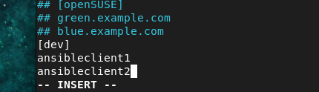

Check the group
Now run:
ansible --list-hosts dev
You should get something similar to:
hosts (2):
ansibleclient1
ansibleclient2

What does [dev] mean?
[dev]
ansibleclient1
ansibleclient2
Here:
- [dev] → Group name
- ansibleclient1 → First managed machine
- ansibleclient2 → Second managed machine

